Scope

The purpose of this lab is to guide you thru setup of the ASA Phone Proxy. ASA Phone Proxy is a new feature within ASA v8.0.4 aimed at providing organizations with the capability to:
- Secures remote phones by forcing the phones to do encrypted signaling and media
- Performs certificate based authentication with remote phones
- Terminates TLS signaling from Phone and initiate TCP to CUCM
- Terminates SRTP and initiate RTP/SRTP to the called party.
This lab is not intended to educate users on the configuration of the Unified Communications Manager or any devices on the remote edge.

Physical Setup

Your lab instructor will provide each group with a Pod Number. The lab guide will use an ‘x’ to signify when to use your Pod Number during the configuration of ASA Phone Proxy.

For your reference, provided on Page 1 is a lab diagram followed by a larger Switch Port Table, Host Table, NAT Table, and VLAN Table on Page 2 to help you with network cabling and IP addressing.

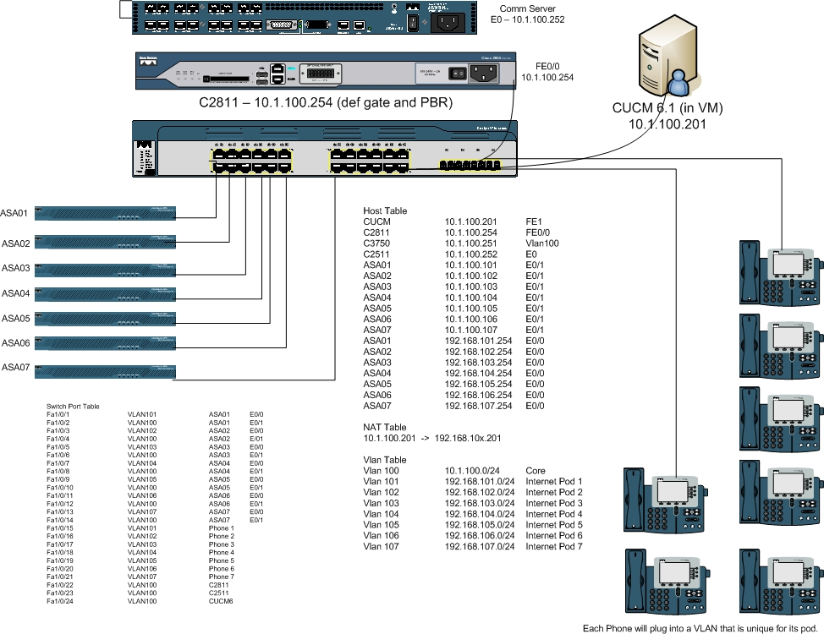

Switch Port Table
Switch Port | VLAN Association | Specified Pod ASA | ASA Ethernet Port
Fa1/0/1 | VLAN101 | ASA01 | E0/0
Fa1/0/2 | VLAN100 | ASA01 | E0/1
Fa1/0/3 | VLAN102 | ASA02 | E0/0
Fa1/0/4 | VLAN100 | ASA02 | E/01
Fa1/0/5 | VLAN103 | ASA03 | E0/0
Fa1/0/6 | VLAN100 | ASA03 | E0/1
Fa1/0/7 | VLAN104 | ASA04 | E0/0
Fa1/0/8 | VLAN100 | ASA04 | E0/1
Fa1/0/9 | VLAN105 | ASA05 | E0/0
Fa1/0/10 | VLAN100 | ASA05 | E0/1
Fa1/0/11 | VLAN106 | ASA06 | E0/0
Fa1/0/12 | VLAN100 | ASA06 | E0/1
Fa1/0/13 | VLAN107 | ASA07 | E0/0
Fa1/0/14 | VLAN100 | ASA07 | E0/1
Fa1/0/15 | VLAN101 | Phone 1
Fa1/0/16 | VLAN102 | Phone 2
Fa1/0/17 | VLAN103 | Phone 3
Fa1/0/18 | VLAN104 | Phone 4
Fa1/0/19 | VLAN105 | Phone 5
Fa1/0/20 | VLAN106 | Phone 6
Fa1/0/21 | VLAN107 | Phone 7
Fa1/0/22 | VLAN100 | C2811
Fa1/0/23 | VLAN100 | C2511
Fa1/0/24 | VLAN100 | CUCM6

Host Table
Platform | IP Address | Port Number
CUCM | 10.1.100.201 | FE1
C2811 | 10.1.100.254 | FE0/0
C3750 | 10.1.100.251 | Vlan100
C2511 | 10.1.100.252 | E0
ASA01 | 10.1.100.101 | E0/1
ASA02 | 10.1.100.102 | E0/1
ASA03 | 10.1.100.103 | E0/1
ASA04 | 10.1.100.104 | E0/1
ASA05 | 10.1.100.105 | E0/1
ASA06 | 10.1.100.106 | E0/1
ASA07 | 10.1.100.107 | E0/1
ASA01 | 192.168.101.254 | E0/0
ASA02 | 192.168.102.254 | E0/0
ASA03 | 192.168.103.254 | E0/0
ASA04 | 192.168.104.254 | E0/0
ASA05 | 192.168.105.254 | E0/0
ASA06 | 192.168.106.254 | E0/0
ASA07 | 192.168.107.254 | E0/0

NAT Table
CUCM IP Address | NATed CUCM IP Address
10.1.100.201 | 192.168.10x.201

VLAN Table
VLAN ID | IP Subnet | Description
Vlan 100 | 10.1.100.0/24 | Core
Vlan 101 | 192.168.101.0/24 | Internet Pod 1
Vlan 102 | 192.168.102.0/24 | Internet Pod 2
Vlan 103 | 192.168.103.0/24 | Internet Pod 3
Vlan 104 | 192.168.104.0/24 | Internet Pod 4
Vlan 105 | 192.168.105.0/24 | Internet Pod 5
Vlan 106 | 192.168.106.0/24 | Internet Pod 6
Vlan 107 | 192.168.107.0/24 | Internet Pod 7

Lab Instructions – Initial Setup

- Associated your Wireless LAN Adapter to the SSID of PhoneProxy.
- Once you have obtained an IP Address via DHCP, telnet to the terminal server at IP Address 10.1.100.252.
- Once inside the terminal server, you will see a menu. Select the ASA associated with your Pod Number (i.e. Pod #1 should chooses ASA1).
- Login to your ASA (there should not be a password).
- Perform a write erase then reload of your ASA.
- If not already done for you by your lab instructor, cable your Pod’s ASA and IP Phone to the designated switch ports as illustrated in the Host Table on Page 2.
- Obtain a copy of ‘asax-pre.txt’ (where ‘x’ denotes your Pod Number) from your lab instructor and save it to your desktop.
- Open the aforementioned text file and copy the contents.
- Paste the contents in your ASA from global configuration mode.
- Perform a wr mem and continue with your lab below.

Lab Instructions – ASA Phone Proxy Configuration

- The ASA Phone Proxy requires you to configure Access Control Lists to allow TFTP and TLS and then apply these ACLs to the Outside interface of your ASA using the following commands (where ‘x’ denotes your Pod Number):

access-list OutList extended permit tcp any host 192.168.10x.201 eq 5061
access-list OutList extended permit udp any host 192.168.10x.201 eq tftp
access-list OutList extended permit tcp any host 192.168.10x.201 eq 2443

access-group OutList in interface Outside

- Next you must configure a static NAT translation for the private CUCM IP address using the following command (where ‘x’ denotes your Pod Number):

static (Inside,Outside) 192.168.10x.201 10.1.100.201 netmask 255.255.255.255

- Now generate an RSA keypair to associate with the self-signed certificate that will be created in Step 4 of this procedure by entering the following command:

crypto key generate rsa label cucm1 modulus 1024

- Create a trustpoint for the CUCM. The trustpoint needs to be in the Certificate Trust List (CTL) file for the phones to trust the CUCM by entering the following commands:

crypto ca trustpoint cucm1
enroll self
keypair cucm1

crypto ca enroll cucm1

- After entering the crypto ca enroll cucm1 command, answer yes to the following two questions.
- Configure the CTL file instance.

ctl-file myctl

- Configure the CUCM trustpoints (where ‘x’ denotes your Pod Number).

record-entry cucm-tftp trustpoint cucm1 address 192.168.10x.201

- Create the CTL file.

no shutdown

- Configure the TLS Proxy instance.
  - Create the necessary RSA keypairs for phones.
crypto key generate rsa label phone_common modulus 1024
  - Create the TLS Proxy instance.
tls-proxy my_proxy
server trust-point _internal_PP_myctl

- Configure the Phone Proxy instance.

phone-proxy pp
tftp-server address 192.168.104.201 in interface Outside
media-termination address 192.168.104.201
ctl-file myctl
tls-proxy my_proxy

- Enable the Phone Proxy for Skinny and SIP inspection:

class-map sec_sccp
match port tcp eq 2443

class-map sec_sip
match port tcp eq 5061

policy-map global_policy
class sec_sccp
inspect skinny phone-proxy pp
class sec_sip
inspect sip phone-proxy pp

service-policy global_policy global

Lab Instructions – Importing Certificates from the CUCM

In order for the TLS proxy to successfully complete the TLS handshake, it will need to verify the certificates from the Phone (and the CUCM if doing TLS with CUCM). To validate the Phone’s certificate, we need the CA Manufacturer’s certificate which is stored on the CUCM. Follow these steps to import the CA Manufacturer’s certificate to the ASA.

- Obtain the files Cisco_Manufacturing_CA.pem.txt and CallManager.pem.txt from your lab instructor.
  - As a side note, in order to obtain the file directly from CUCM, from the CUCM’s OS Administration page, you would click on Security → Certificate Management.
  - Click “Find.”
  - Find the filename “Cisco_Manufacturing_CA” or “CallManager” and click on it.
  - Then click on “Download” and save the file as a text file.

- On the ASA, create a trustpoint for the Cisco Manufacturing CA and have it enrolled vial terminal since we will cut and paste the certificate we just downloaded.

crypto ca trustpoint cisco_manu_ca
enroll terminal
crypto ca authenticate cisco_manu_ca

- You should now be asked to “Enter the base 64 encoded CA Certificate” so you will need to copy the Cisco_Manufacturing_CA.pem.txt file you obtained from your instructor and paste it here. The file is already base 64 encoded so no need to do the conversion.
- After you have pasted in the cert, hit the Enter key to enter a carriage return.
- Now, type the word “quit” and hit Enter.
- If the certificate is OK, it will ask you “Do you accept this certificate? [yes/no]:”
  - Enter “yes” and hit Enter.
- On the ASA, create a trustpoint for the Cisco Manufacturing CA and have it enrolled vial terminal since we will cut and paste the certificate we just downloaded.

crypto ca trustpoint cisco_uc_manu
enroll terminal
crypto ca authenticate cisco_uc_manu

- You should now be asked to “Enter the base 64 encoded CA Certificate” so you will need to copy the CallManager.pem.txt file you obtained from your instructor and paste it here. The file is already base 64 encoded so no need to do the conversion.
- After you have pasted in the cert, hit the Enter key to enter a carriage return.
- Now, type the word “quit” and hit Enter.
- If the certificate is OK, it will ask you “Do you accept this certificate? [yes/no]:”
  - Enter “yes” and hit Enter.
- Finally, perform a wr mem on the ASA and then reboot it.
Lab Instructions – Troubleshooting

The following illustrates some of the troubleshooting commands you may use to help you decipher any problems you may have with your ASA Phone Proxy configuration. In addition, sample output from the commands has also been provided as a comparison.

On the ASA

debug phone-proxy signaling [events|errors]

debug phone-proxy tftp [events|errors]
- Sample “debug phone-proxy tftp” output of failure:
PP: 64.169.58.181/13859 requesting SEP001E7AC54CE9.cnf.xml.sgn
PP: opened 0x3311f3be
PP: (192.168.200.101/39420 -> 64.169.58.181/9014)
File not found
PP: Config file SEP001E7AC54CE9.cnf.xml.sgn not found for client outside:64.169.58.181/9014 server inside:192.168.200.101/39420
PP: closing tftp-data conn 0x3311f3be
PP: closing tftp-data conn 0x33110a32

- Sample output of “debug phone-proxy tftp” for successful TFTP transaction for config file request:
PP: 98.208.49.30/1028 requesting SEP00070E364804.cnf.xml.sgn
PP: opened 0x33952aa2
PP: Received data from 192.168.200.101 to outside:98.208.49.30/1028
Received Block 1
PP: Acked Block #1 from 98.208.49.30/1028 to 192.168.200.101/39514
.... [snip].....
PP: Received data from 192.168.200.101 to outside:98.208.49.30/1028
Received Block 10
PP: Acked Block #10 from 98.208.49.30/1028 to 192.168.200.101/39514
PP: Installed application redirect rule from 98.208.49.30 to 192.168.200.101 using redirect port 2000 and secure port 2443
PP: Modifying to TLS as the transport layer protocol.
PP: Modifying to encrypted mode.
PP: Data Block 1 forwarded from 192.168.200.101/39514 to 98.208.49.30/1028
PP: Received ACK Block 1 from outside:98.208.49.30/1028 to inside:192.168.200.101
...... [snip] ....
PP: Data Block 11 forwarded to 98.208.49.30/1028
PP: Received ACK Block 11 from outside:98.208.49.30/1028 to inside:192.168.200.101
PP: TFTP session complete, all data sent

show phone-proxy secure-phones

asa_phone_proxy: 3 in use, 4 most used

Interface/IP Address MAC Timeout Idle
--------------------------- ---------- --------- ------
outside:69.181.112.219 001e.7ac4.da9c 0:05:00 0:00:16
outside:69.181.112.219 0002.b9eb.0aad 0:05:00 0:00:58
outside:98.208.49.30 0007.0e36.4804 0:05:00 0:00:09

show phone-proxy media-session
Media-session: 128.106.254.3/1168 refcnt 6
<---> RTP connection to 192.168.200.106/25038 tx_pkts 485 rx_pkts 491
Media-session: 128.106.254.3/1170 refcnt 6
<---> SRTP connection to 98.208.25.87/1030 tx_pkts 484 rx_pkts 485

On the IP Phone
- Check the Security settings on phone to see if the phone’s Security Mode has been converted to “Encrypted”
- Check phone to ensure either MIC or LSC is present
- Check the Status messages on the phone.
- Connect to the phone through HTTP and get console logs

