

TM



**Advanced Services**

**Advanced Services**

Agent Multiline Control Support in UCCE

Version 0.1

**Corporate Headquarters**

Cisco

170 West Tasman Drive

San Jose, CA 95134-1706

USA

<http://www.cisco.com>

Tel: 408 526-4000

800 553-NETS (6387)

Fax: 408 526-4100

# Contents

Contents 1

About this Document 2

History 2

Review 2

Document Purpose 2

Related Documents 2

Integration Requirements 2

Proposed Solution 6

Reliability and Scalability 7

Routing Logic 7

Call Flow 8

# About this Document

Author: Loyd Vest, Cisco Advanced Services

## History

Table 1 - Revision History

| Version No. | Issue Date | Status | Reason for Change |
| --- | --- | --- | --- |
| 0.1 | 2/1/2011 | First Draft | Initial draft |

## Review

Table 2 - Revision Review

| Reviewer’s Details | Version No. | Date |
| --- | --- | --- |
|  |  |  |

## Document Purpose

This document is intended to provide a high-level overview of Multiline support within the UCCE 8.0(1) environment, and specifically the support and functionality of Multiline phones from a CTIOS Agent Desktop perspective.

## Related Documents

1. CTI Server Protocol Specification Version 15
2. CTIOS Developer’s Guide version 8.0

# Overview

New with UCCE 8.0(1) is the support for configuring multiple lines on the Agent’s IP Phone. Having multiple lines configured on the IP Phone has been support by UCM for years, but was not supported with UCCE.In the past, if multiple lines were configured UCCE could not monitor those additional lines on an Agent’s IP Phone.

With release 8.0(1), the Agent’s phone can now be configured with one ACD Line and multiple Non-ACD Lines (i.e. up to four total lines).

The Agent Multiline Control feature allows reporting and call control for calls on the configured secondary line(s) on the agent’s phone for up to four total lines. This includes support for Join Across Line and Direct Transfer Across Line on all Cisco model phones that support these features.

Multiline is enabled through configuration for the peripheral. It applies to all agents who log into that peripheral.

Siebel and Mobile Agent do not support the Agent Multiline feature. If using Siebel or Mobile Agent CTI port devices, Unified CCE 8.0 (1) requires that a Single line be configure for both.

Other than placing a call, all other call control on the non-ACD extensions is supported from Multi Line capable desk tops, except for call initiation. Calls initiated from the hard phone can be controlled after initial call setup.

Shared lines and Call Park features are not supported on ACD and non-ACD lines.

Unified CCE may not be backward compatible with third-party CTI Server Applications when Multi Line Agent Mode is enabled. Multi-line support must be validated with the third-party vendor.

# Configuring Multiline in Configuration Manager

There are two new peripheral-wide settings for Agent Multiline Control. These settings are configured on the Peripheral tab of the PG Explorer (see Figure 1 below). They are:

* Agent Phone Line Control: Single Line or MultiLine: The default setting for Agent Phone Line control is **Single Line**, which means that the agent has one line on the phone. If the agent has additional lines on the phone, you can change the default to **Multiline**.

The Multiline setting allows for a maximum of four extensions per phone. One of these is the ACD line (this is the extension to agent logs into). The other three are non-ACD lines. The agent desktop displays calls from all extensions, and calls from all extensions can be controlled (answered, conferenced, joined, and transferred).

Note that the following options are *not* supported in Agent Multiline Control mode:

* + Call Park and Shared Lines are not supported on non-ACD lines.
  + Call waiting is not supported on any of the lines; however, lines can be configured to forward on busy to secondary lines.
* Non ACD Line Impact: There are two options on the Peripheral tab of the PG Explorer for the Non ACD Line Impact setting:
  + **Available Agent Stays Available** means the agent remains “Available” even while talking on a non-ACD line.
  + **Available Agent Set Not Ready** means that the agent state changes to Non Ready with a special reason code while the agent is talking on, or is on hold on, a non-ACD line. This state change occurs when the agent initiates or answers a call on a non-ACD line.

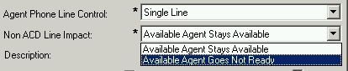

Figure 1 PG Explorer Settings

When you set the Agent Phone Line Control to allow multiline support, the PG Explorer will display a Warning Dialog box, see Figure 2 below.

The Warning describes the configuration that must be done on the Unified Communication Manager when configuring multiline support in conjunction with UCCE. Specifically that the following setting are made correctly for every line on each phone device or CTI Port that the Agent might want to use:

* Requires that the busy trigger of 1 (i.e. no call waiting) is set, although calls can be forwarded to other extensions on the phone when busy.
* Requires that the maximum number of calls are set to 2.

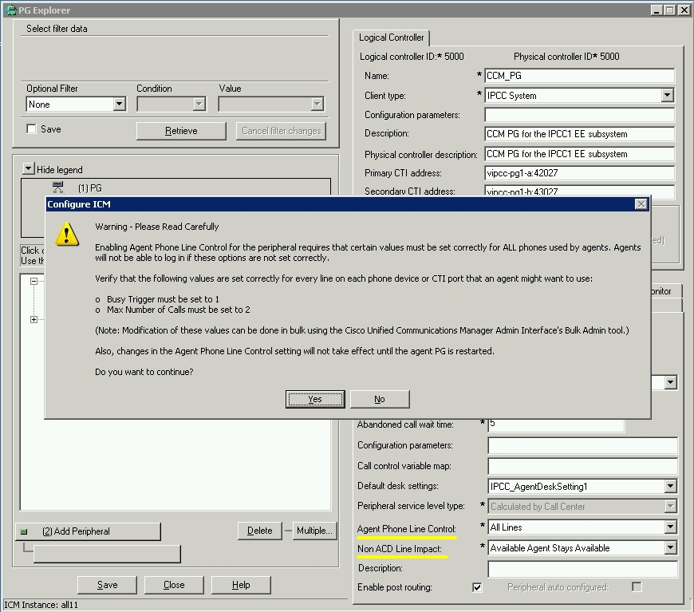

Figure 2 Warning Dialog

# UCCE Changes to support Multiline

## Schema

New fields were added to two Schema tables to track Agent Multiline Control:

**•**The Agent_Interval (Agent_Historical) table has four new fields for calls on the non-ACD line extensions: NonAcdCallsInCount, NonAcdCallsInTime, NonAcdCallsOutCount, NonAcdCallsOutTime. (For more details, refer to the *Database Schema Guide for Cisco Unified ICM/Contact Center Enterprise & Hosted*.)

**•**The Termination_Call_Detail table has a new Peripheral Call Type for non-ACD calls. The call type is DBCD_NON_ACD, and the associated value is **38**. This call type monitors calls to or from an unmonitored device or another non-ACD line.

## Reporting

Reporting on Agent MultiLine Control is not available. No stock WebView or Unified IC report templates use the new Agent Interval fields.

CTI Server

A new CTI Server Protocol, version 14, published with UCCE v8.0(1) to support the new Agent Multiline Control.

**The Summary of CTI Server Changes related to Multiline are:**

* Added DEVID_NON_ACD_DEVICE_IDENTIFIER and DEVID_SHARED_DEVICE_IDENTIFIER as new DeviceID Types
* Added non ACD line types LINETYPE_NON_ACD_IN, and LINETYPE_NON_ACD_OUT as new Line Types
* Added calltype CALLTYPE_NON_ACD (38) as a new call type
* OPEN_CONF: Added NumPeripherals, FltPeripheralID, and MultilineAgentControl
* Added  (New for V14) new failure code
  + CF_MAXIMUM_LINE_LIMIT_EXCEEDED
  + CF_SHARED_LINES_NOT_SUPPORTED
  + CF_EXTENSION_NOT_UNIQUE
* Added to service masks  CTI_SERVICE_ACD_LINE_ONLY
* Connecting clients that use versions prior to version 14 is strongly discouraged but not prevented by CTI-Server.  An alarm will be raised when Multi Line is enabled on a peripheral and the client connects with older protocol version.
* When Multi Line mode is enabled on a peripheral, if a CTI client connects with an protocol revision older than 14, events will still be received for those calls, but, given the new device/subject identifier form, they shouldn't be recognized as calls on that agents primary device.
* For clients using a protocol less than 14, or for clients that are using 14 that have set the CTI_SERVICE_ACD_LINE_ONLY service mask, after sending a SNAPSHOT_DEVICE_REQ, the SNAPSHOT_DEVICE_CONF received will only contain calls on the agents primary (ACD) line. Calls on the non-ACD lines will not be returned.
* The contents of DeviceID fields are changed to include the instrument, extension, and line position. This is being done primarily for serviceability and tracing, but it is believed that it will make other Multiline features easier to use in the future.
* Format of the Device ID  
  Clients will see a string containing the instrument (Agents primary extension), a dot ('.'), then the actual extension of that device, then a dot plus the extension (line) position on the device.  Note that this is visible in all versions of the protocol.  Non subject device fields (DNIS/ANI) will not have this format.  For calls on the primary extension these will be truncated to just the primary extension.  (i.e. Instead of seeing 1000.1000.1 you'll see 1000).
* ConnectionDeviceID  
  ConnectionDeviceIDs will use this same format.
* Impact to apps that don't care about this new information:
  + This information will impact all applications if Multi Line is used - If they stay v13 or lower, and the Multi Line Agent feature is enabled, the CTI application will see the enumerations for Line Type, Call Type, Device ID Type, and Device ID fields will contain the new dotted format. If the application does not recognize the device ID type or the dotted format, we expect that these connections will assume to be unmonitored devices, but older applications should test with the new fields to verify.
  + If new applications do not wish to see these calls on a SNAPSHOT_DEVICE_CONF they should request the CTI_SERVICE_ACD_LINE_ONLY in the OPEN_REQ service mask.  Note that this does not affect events, just the visibility of calls on a SNAPSHOT_DEVICE_CONF.
* Impact to apps desiring to use this new data:  
  Apps that want this new data will need to change their implementation code to decode the extension and position suffix in the Device ID to utilize it.
* Functionality with third party requests:  
  This scheme works with third party requests, allowing the clients to specify the extension that an operation (Such as Make Call) should be performed on.

## CTIOS Server

The CTIOS Server was changed to support the new CTI Server Protocol 14. Along with the new DeviceID Types, Line Types, and Call Types. No other functionality was changed in CTIOS Server to support Agent Multiline Control.

* + No changes to API. Session will contain call objects for the event.
  + Device id changes but there are no objects for device ids.

CTIOS Client Interface Library

There are no changes to the CTIOS Client Interface Library. The Non-ACD line calls will be received by the Session object, and will be treated just like the ACD Line calls. The only difference will the Device IDs that will be received in the Call Events as described above in the CTI Server section.

The client desktop will need to keep track of the Non-Acd Line Call, just like it would a consultation call. Button Enable Mask Change events will be received for the Not-Acd line call. If using a grid to display calls, the Current Call paradigm as described in the CTIOS Developers Guide must be used for both the ACD Line call and the Non-ACD line call (i.e. set the Current Call to the call currently high-lighted in the grid). The button enablement will reflect the setting of the current call, so that the appropriate buttons will be enabled.

The CTIOS Desktop client cannot initiate a call on the Non-ACD Line. However, once the call has been initiated all other control can be initiated from the Client (i.e. Hold, Answer, Transfer, Conference, etc…).

The Join Across Lines (JAL) and Direct Transfer Across Lines (DTAL) are not supported from the CTIOS Client Interface Library. These features require the use of the IP Phone. However, the UCCE system, including the CTIOS Server and CTIOS Client, will reflect the correct state of the call(s) after these operations have been completed.



TM

