

Key System

Solution Guide

Document Version 1.2

9737 Washingtonian Blvd; Suite 350

Gaithersburg, MD 20878

Tel +1 301.977.9440

Fax +1 301.977.8846

www.broadsoft.com

BroadWorks® Guide

Copyright Notice

Copyright © 2014 BroadSoft, Inc.

All rights reserved.

Any technical documentation that is made available by BroadSoft, Inc. is proprietary and confidential and is considered the copyrighted work of BroadSoft, Inc.

This publication is for distribution under BroadSoft non-disclosure agreement only.   
No part of this publication may be duplicated without the express written permission of BroadSoft, Inc. 9737 Washingtonian Blvd, Suite 350, Gaithersburg, MD 20878.

BroadSoft reserves the right to make changes without prior notice.

Trademarks

Product names mentioned in this manual may be trademarks or registered trademarks of their respective companies and are hereby acknowledged.

This document is printed in the United States of America.

Document Revision History

|  |  |  |  |
| --- | --- | --- | --- |
| Version | Reason for Change | Date | Author |
| 1.0 | First version | October 2012 | David Block |
| 1.1 | Hybrid Solution changes | January 2014 | David Block |
| 1.2. | Edit for clarity | April 2014 | Asif Rehman |
|  |  |  |  |
|  |  |  |  |
|  |  |  |  |
|  |  |  |  |
|  |  |  |  |
|  |  |  |  |
|  |  |  |  |

Table of Contents

1 Document Purpose 5

2 Basic Key System Solution 6

2.1 Solution Description 6

2.2 Solution Configuration on BroadWorks 8

2.3 Additional Capabilities 15

2.4 Device Configuration Requirements 15

2.4.1 Supported Device Models 15

2.4.2 Device Requirements 15

2.4.3 Device Configuration Details 17

3 Hybrid Key System Solution 18

3.1 Solution Description 18

3.2 Solution Configuration on BroadWorks 20

3.3 Device Configuration Requirements 23

3.3.1 Supported Device Models 23

3.3.2 Device Requirements 23

3.3.3 Device Configuration Details 25

# Document Purpose

This documentation will describe setting up a Basic and a Hybrid Key System solution. The document will also describe the configuration details for the supporting devices.

# Basic Key System Solution

## Solution Description

The emulation of an NxM Basic Key System solution can be achieved through simple provisioning on BroadWorks. The Key System will support a maximum of N simultaneous calls and these calls will be distributed across M number of handsets deployed within the business. The call appearances available to the business are managed by a single user instance on BroadWorks. The user at the handset can make outbound calls using an available line to place the outbound call. In our example we will provision a 3x6 Key System as shown in the diagram below.



Figure 1 Key System Solution Diagram

When a call comes into the business or Key System, the call is alerted on all handsets assigned as a key system endpoint. The diagram below shows an example display of three handsets with an alerting call on line key 1 and the calling line ID presented. For simplicity only the first three handsets are shown in our example.





Figure 2 Key System incoming call

The call is answered at handset 2 and is released at handsets 1 and 3. The line key lamp at handset 2 is updated to indicate it has the active call. Handsets 1 and 3 line key lamps indicate that the call is active at another handset.



Figure 3 Call answered at handset 2

A second call comes into the business and is alerted at all handsets on line key 2. The diagram below shows the alerting call on line key 2 of each handset with the calling line ID presented.



Figure 4 A second call incoming on Line 2

The second call is answered at handset 3 and release at handsets 1 and 2. The line key lamp for line key 2 on handset 3 is updated to indicate an active call. The line key lamp for line key 2 on handset 1 and 2 are updated to indicate that the active call is present on another handset.



Figure 5 Call answered at handset 3

The call at handset 3 is now put on hold. The line key lamps for line key 2 on all handsets are update to indicate the call state is now in the on Hold state.



Figure 6 The second call placed on hold

The call is taken off hold at handset 1. The connected party calling line ID is displayed for the active call. The line key lamp for line key 2 on handset 1 is updated to indicate an active call on this line. The line key 2 lamps for handsets 2 and 3 are updated to indicate that the active call is at another handset.



Figure 7 The second call taken off hold at handset 1

The user at handset 3 makes an outbound call on line key 3. The line key lamps for line key 3 on handsets 1 and 2 are now marked with an active call on another handset as show in the diagram below.



Figure 8 User at handset 3 initiates an outbound call

At this point, all the lines for this Key System are active. No more inbound or outbound calls can be received/made until a line becomes idle. Any new calls coming into the business at this point will be provided with treatment. If the Key System is assigned with the Voice Messaging service, then this call can be routed to this service.

## Solution Configuration on BroadWorks

This section will describe the required BroadWorks provisioning to create the Basic Key System solution. In our example we will provision 3x6 Key System.

The 3x6 Keys System means that 3 simultaneous calls may active at one time within the business and these calls may be originated/terminated from/to any of the 6 available handsets deployed within the business. To represent the end business a Group on BroadWorks will be created. The line into a business will be represented as a BroadWorks User instance***. Since only one user is required to configure an NxM Basic Key System, only a single Premium Enterprise license is required.***

The Calling Line ID provisioned for this BroadWorks User will be the Calling Name data that represent the business. All calls exiting the business will use the provisioned Calling Name data provisioned for this user/Key System.

The figure below shows the Calling Line Identity fields provisioned for our Key System user.

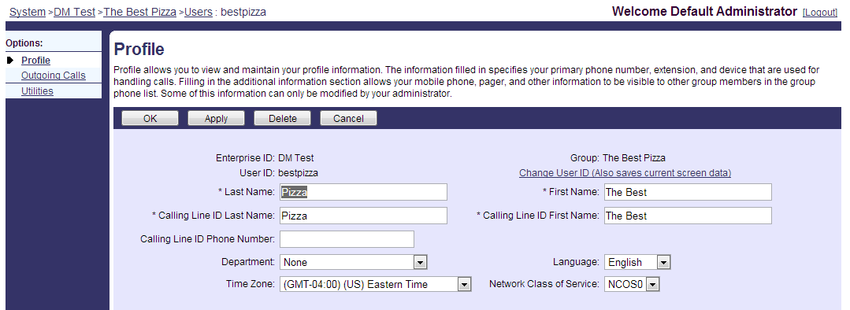

Figure 9 User Profile page provisioning

This BroadWorks user will be allowed to receive a maximum of 3 concurrent calls. This call limit will be defined in the Call Processing Policies for the BroadWorks User. The Call Processing Policies are available under the BroadWorks User’s Profile page. In the Call Limits section, the *Use User Call Limits Policy* should be selected. Next, the *Enable Maximum Number of Concurrent Calls* policy must be set to the maximum calls that the Key System can receive. In our example we are defining a 3x6 Key System, so this value must be set to 3. Other call limits can be defined for maximum video calls and call durations for answered or unanswered calls. An example of this provisioning is shown in the figure below.

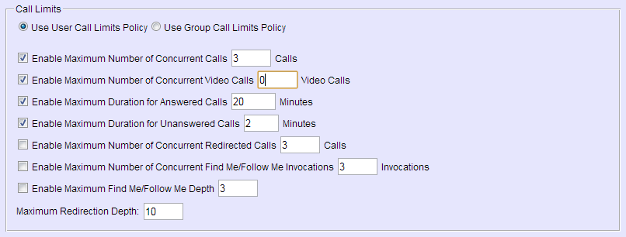

Figure 10 User Call Procession Policies Call Limits provisioning

The calls will be shared across the handsets using the Shared Call Appearance/Multiple Call Arrangement services. At a minimum, this user instance must be assigned with the Call Waiting, Shared Call Appearance and Multiple Call Arrangement services. The Shared Call Appearance service assigned will depend on the number of handset (M) deployed at the business. This service will allow up to 35 handsets to be deployed with service version of 3, 5, 10, 15, 20, 25, 30 and 35. In our example we are supporting 6 handsets in the business, so the Shared Call Appearance 5 service must be assigned. The remaining handset is provisioned as the BroadWorks Users main line. The user can also be provisioned with the Voice Messaging service to redirect calls when the maximum number of concurrent calls is reached or when the call is not answered. The services are assigned via the *Assign Service* link under the User’s Resources Page. For our example we will only add the Authentication, Call Waiting, External Calling Line ID Delivery, Multiple Call Arrangements and Shared Call Appearance 5 services.

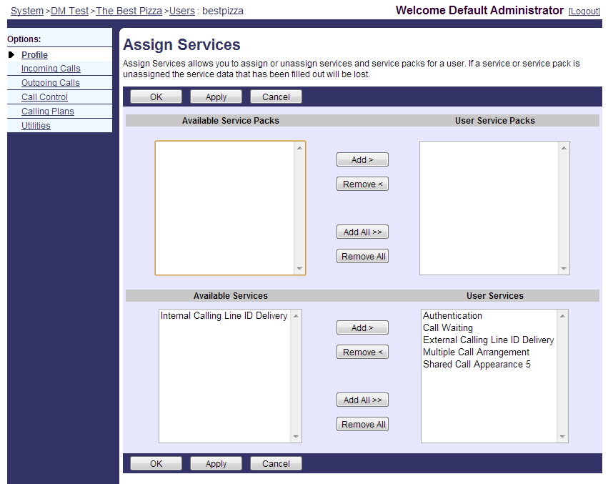

Figure 11 Assign Services page for the Key System User

The Authentication service will define the SIP Authentication credentials for this user’s device. The External Calling Line ID Delivery will allow BroadWorks to send the Calling Name/Number for calls made outside the business. The Call Waiting Service is automatically assigned with the service enabled, so no other provisioning is required for this feature.

For the Shared Call Appearance Service, Device Profiles will need to be created for the device that will be deployed at the end business. In our example we will need to create 6 device profiles for each of the handsets deployed. These device profiles are created on the Identity/Device Profiles page located on the *Group-Resources* page. The Device Profile needs to be given a Name, a Device Type at the minimum. If Device Management is being used to configure the devices, then a Device Management Username and Password will also need to be defined. In our example, we are using the Cisco SPA-504 device for each of the Key System handsets. An example of this provisioning is shown in the figure below.

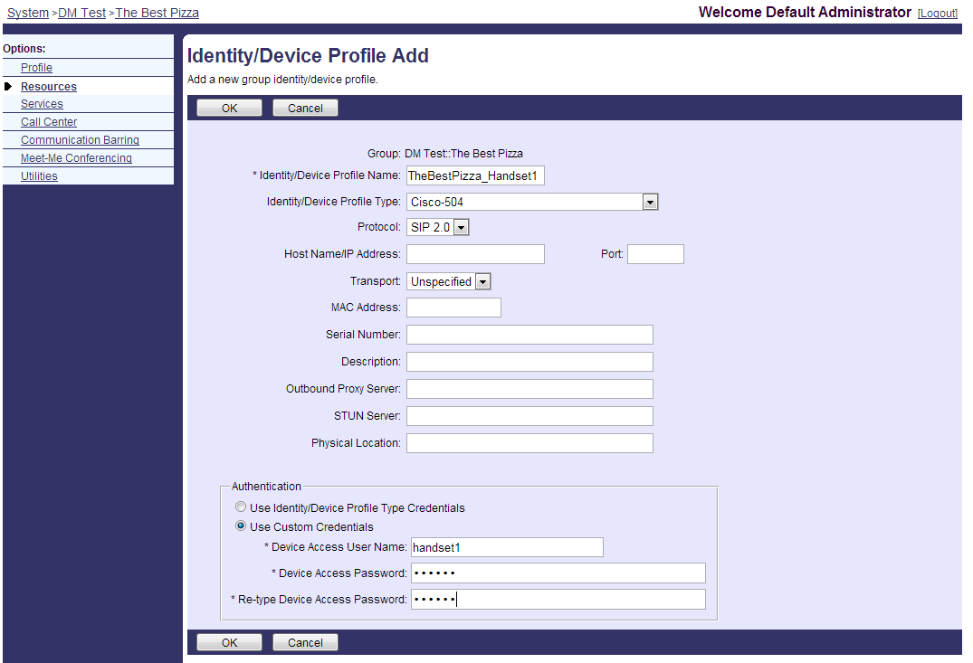

Figure 12 Add Device Profile page

To assign the Device Profiles to the Key System, one Device Profile will be assigned as the user instance main device and the remaining will be assigned via the Shared Call Appearance Service. In our example we will assign Handset 1 Device Profile as the user’s main device and the remaining Device Profiles to the Shared Call Appearance.

Under the user’s *Addresses* page, the Key System main device will be assigned. On this page the Directory Number (DN) for the Key System is defined from the list of available DNs. In our example we are assigning the Key System with a Directory Number of 9998881500 and an extension of 1500. The AceHardware_Handset 1 Device Profile is selected from the drop down menu and the Line/Port field is defined with any unique address of record. In our example we will use the *DN_handsetX*. An example of this provisioning is show in the diagram below.

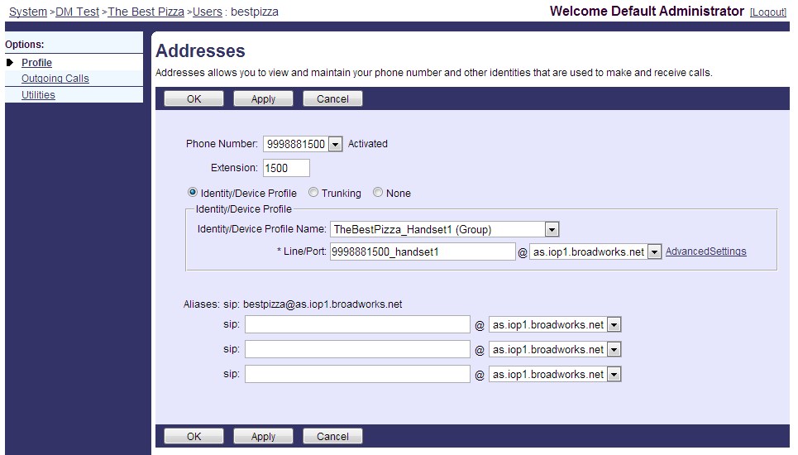

Figure 13 Provisioning Key System DN and Main Line Device Profile

On the Shared Call Appearance Add page, the remaining 5 Device Profiles will be added. The Shared Call Appearance page is accessible from the *User-> Call Control* page. The Add button is pressed to add the Device Profiles. The Device Profile is selected from the drop down menu and the line port field is provisioned with the unique address of record. In our example diagram below shows the Shared Call Appearance service being provisioned with the Device Profile for Handset 2. The line/port field uses the same format used to provision the main line device. In our example this will be *9998881010_handset2*. This provisioning will be repeated for the remaining device profiles. The figure below shows an example of adding the device profile to the Shared Call Appearance Service.

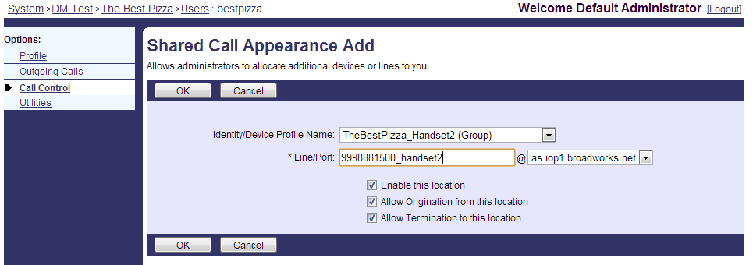

Figure 14 Add Device Profile to Shared Call Appearance

Lastly, on the Shared Call Appearance page, the Multiple Call Arrangements service must be turned on and Call Bridging feature must be enabled along with the Bridge warning tone setting. The figure below shows an example of the Shared Call Appearance page.

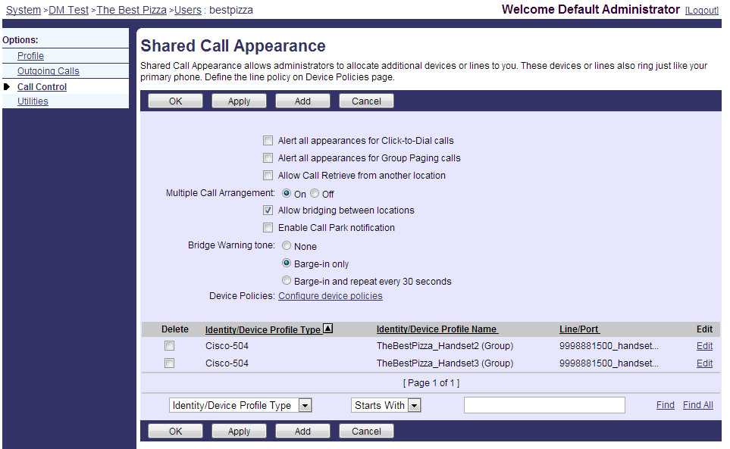

Figure 15 Enable Call Bridging and Multiple Call Arrangements

Configuring the Calling Plan Services need to be added and defined for the business. The Calling Plan services are assigned to the group under the *Resources.* On the Resources page the *Assign Group Services* link is pressed. On this page the Administrator assigns the Incoming and Outgoing Calling Plan services. An example of this provisioning is shown in the figure below.

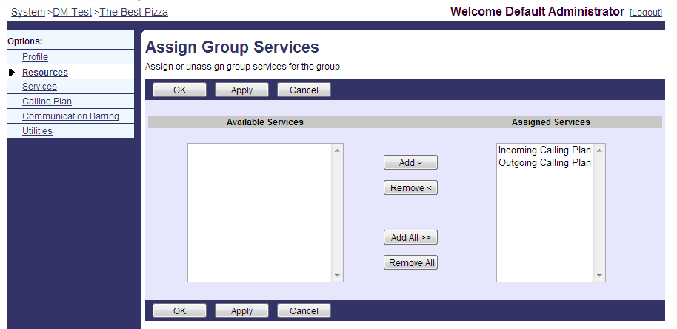

Figure 16 Assigning the Calling Plan services

The Incoming Calling Plan service will define the calls that are allowed to come into the business. The figure below shows an example of the Incoming Calling Plan service provisioning.

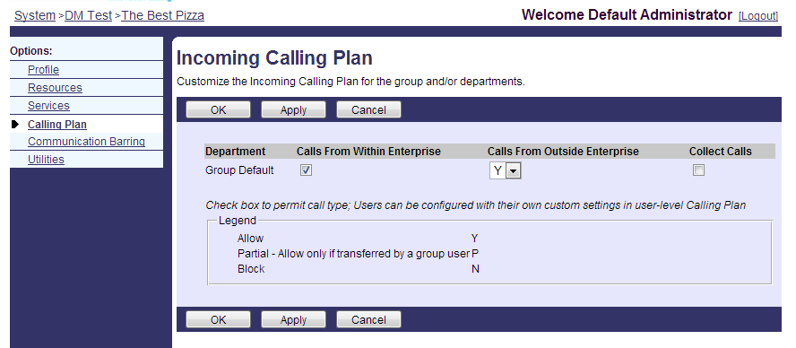

Figure 17 Incoming Calling Plan service provisioning

The Outgoing Calling Plan service will define the calls that are allowed to be made from the business. The figure below shows an example of the Outgoing Calling Plan service provisioning.

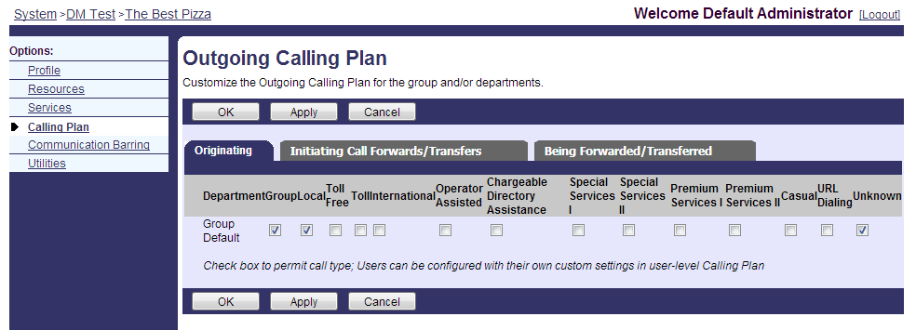

Figure 18 Outgoing Calling Plan service provisioning

The provisioning of the Key System on BroadWorks is now complete and ready for the devices to register for service. The device configuration requirements will be described in the next section.

## Additional Capabilities

Additional system capabilities like overhead paging and doorphone can be added to the basic key system. Each of these capabilities requires a user programed on the system and the device associated to the user. In many cases this will be an ATA connected to analog paging systems and analog doorphones. Some IP versions of these systems are available and would eliminate the need for the ATA.

Each additional user would require an additional user license on the system.

## Device Configuration Requirements

### Supported Device Models

|  |  |
| --- | --- |
| **Supported Device Models** | |
| Vendor | **Device Models** |
| Aastra | Aastra 675xi, 673xi |
| Cisco | Cisco SPA-500, Cisco SPA-300 |
| Polycom | SoundPoint IP and VVX models (line keys share the same label). |
| Yealink | Yealink T3x, VP530 |

### Device Requirements

To support the Key System solution the device must support the following capabilities:

1. The device must support the BroadWorks Shared Call Appearance feature.
2. The device must be able to assign multiple line keys to a single line on the phone.
3. The device must be able to assign one call appearance to each line key or provide the ability to roll a new call over to the next free line key.

An example provisioning is shown for the Cisco SPA-500/300 series phone models. The configuration detail below shows how the Cisco SPA-500/300 series phones maps a line key to a line and defines a label to that key.

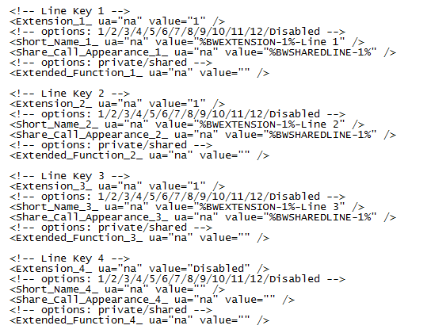

Figure 19 Cisco SPA template file with Device Management Tags

The Extension parameter for each line key is assigned a value of “1” linking each line key to line 1 on the device. The short name value is defined with the label for each line key. In this field we use the Device Management tag %BWEXTENSION-1% plus “-Line X”. In our example this will resolve the labels for the first 3 Line Keys as *“1010-Line 1”, “1010-Line 2” and “1010-Line 3”.* The %BWSHAREDLINE-1% defines each of these line keys as a *“shared”* line.

The Cisco phones will support up to 9 call appearances on a single line. To allow the phone to use a call appearance on a line key and then roll over to the next line key for the next call, the line mapping parameter must be defined to “Vertical First”.



Figure 20 Enable line key rollover

Call Services like transfer, conferencing and forwarding should be disabled at the device. See the provisioning item below. This configuration will remove the display of the feature soft keys on the device.

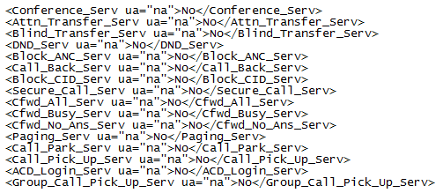

Figure 21Disable enhanced call features at the device

### Device Configuration Details

In addition to the above device configuration example, more details for KTS device configuration can be found in the following Partner Configuration Guides (PCGs).

(http://xchange.broadsoft.com/php/xchange/support/broadworks/integration/cpe)

* Yealink
* Grandstream
* Fanvil
* Polycom coming with R20 update

# Hybrid Key System Solution

## Solution Description

In this solution is the same as the Basic solution, but each station has a private user extension. The user instances in this solution can be enabled with call features such as Call Transfer, Call Pickup, Call Park and Voice Messaging. This allows calls coming into the business to be redirected to the private extensions or to make or redirect calls between the private extensions. To originate calls outside the business, the user must still use one of the call appearances coming into the business. In our example we will define a 3x6 Hybrid Key System Solution. In this solution 3 Call Appearances (via 1 assigned line) come into the business and are directed to the 6 phones within the business.



Figure 22 Hybrid Key System Solution diagram

Each handset will be provisioned with the three lines coming into the business with the main line number extension (1500) and the line number (L1, L2 or L3). The handset will also be provisioned with the user’s personal extension. The diagram shows the display for Extension 1501. Each private extension is represented by a BroadWorks User within the group.



Figure 23 Line key layout on phone display

The user can originate a call within the business from any of the line appearances on the device to any of the other private extensions (1502-1506). The user can only make outgoing calls from one of the 1500 line appearances. The call functionality described for the Basic Key System solution also applies to the Hybrid Key System. The only additional feature that is supplied in the solution is that the users have private extensions and can dial the other extensions (users) in the business. By having private extensions, many advanced features can be enabled like call transfer, call park, pickup, hunt groups, etc.

In our example a call comes into the business and is directed to the six handsets provisioned. Only the first three handsets are shown in our diagrams below.



Figure 24 Incoming call to the Key System

The call is answered at the extension 1501 handset and is released at the extension 1502 through 1506 handsets. The line key lamp at extension 1501 handset is updated to indicate it has the active call. Extension 1502 through 1506 handset line key lamps indicate that the call is active at another handset as show in the figure below.

Figure 25 Call answered at the extension 1501 handset

The call answered at Extension 1501 is intended for the user at Extension 1502, so Extension user 1501 makes a call to Extension user 1502. The call on the main line is put on hold and a call to extension 1502 is made from the private extension as shown in the figure below.

Figure 26 Line 1 call on hold, Extension 1501 user calls extension 1502 user

The call is answered at Extension 1502. The line lamps indicate that handsets 1501 and 1502 are in an active call. Extension 1501 user announces that the call on L1 is for Extension user 1502. See the figure below showing the active calls at Extensions 1501 and 1502.

Figure 27 Extension 1502 user answers call

Extension users 1501 and 1502 release the call. Extension user 1502 then presses the line key for 1500 L1 taking the call on this line off hold. Extension user 1502 now has a voice path with the external user on this line.

Figure 28 Extension 1502 user removes call on line 1 from hold

The incoming call answered at extension 1501 as shown in figure 24 can be handled in a different manner if desired. This call could be transferred from 1500 L1 to private extension 1502. If this method for handling calls is desired, then the BroadWorks User instance for the Key System will need to be assigned with the Call Transfer service to enable the call transfer functionality.

## Solution Configuration on BroadWorks

The Hybrid Key System solution will follow the exact same provisioning steps defined in the Basic Key System provisioning defined in section 2.2, with the additional steps defined in this section.

In this solution each handset will have a private extension and calls can be made between these extensions. To allow calls between the extensions a BroadWorks user must be created, assigned an extension number and assigned a device profile. First a BroadWorks User instance is create for each extension, 6 in total for our example. The Calling Line ID information can be configured with the user’s first and last names. The figure below shows an example of provisioning the user’s Calling Line ID information.

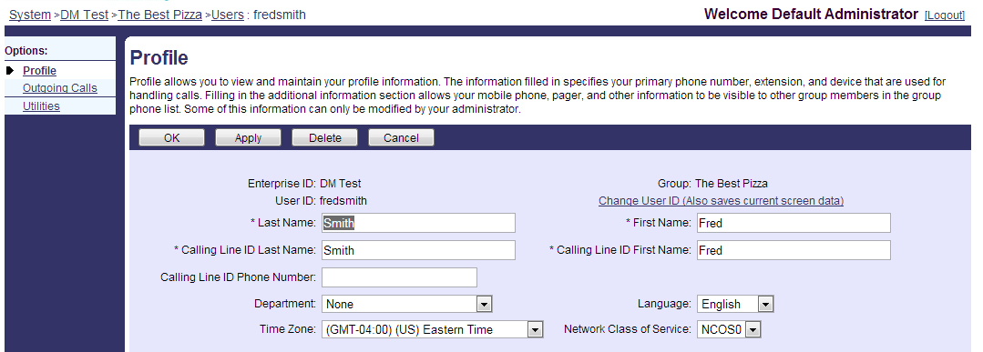

Figure 29 Configuring Extension Users Calling Line ID information

Each of these users will be assigned with an extension. This extension will define how they are reached via dialing by the other users assigned to the Key System. The user’s extension is defined on the *Addresses* link under the user’s profile page. On this page the extension field is defined with the user’s extension. In our example user 1 is assigned with an extension of 1501. On this page we also need to define the handset that this user instance will use and the line/port that this device will register with. In our example we are assigning handset 1 to user 1, handset 2 to user 2, etc. The line port needs to be defined with any unique data. In our example we will use the *groupname_extension* as the unique identifier for the line/port. This configuration is repeated for the other 5 user instances. The figure below shows the configuration for User 1 device assignment.

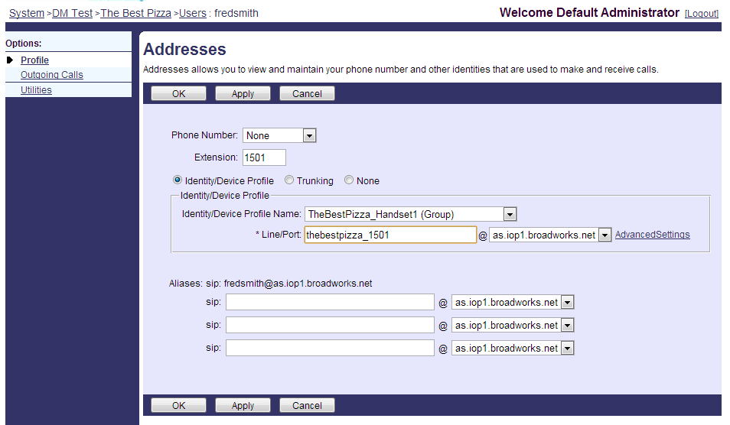

Figure 30 Assigning Extension and Device Profile to User instance

The user instances are now set up such that users can make calls between the user instances.

The user can only dial the 1501-1506 extensions from these user lines. All other calls will be blocked. The administrator may define call limits to these user lines. However, these lines can only make calls within the business, so setting call limits is not really necessary.

The services that will be assigned to these users will include Authentication, Call Waiting and the Internal Calling Line ID Delivery services. The Authentication service will define the SIP Authentication credentials that the device will need to use to authenticate the access to this user line. The Call Waiting service will allow multiple calls appearances to be presented to the device. The Internal Calling Line ID Delivery service will allow this users calling name/number to be presented to the destination. An example of this service assignment is shown in the figure below. Other services such as Call Transfer, Call Pickup, Call Park and Voice Messaging may be assigned to provide the user with advanced calling features. Note, if you wish to enable the advanced calling features above, these features should also be assigned to the Key System user that was created in the Basic Key System solution. This will allow these features to be enabled for calls that come into the business on the Key System line.

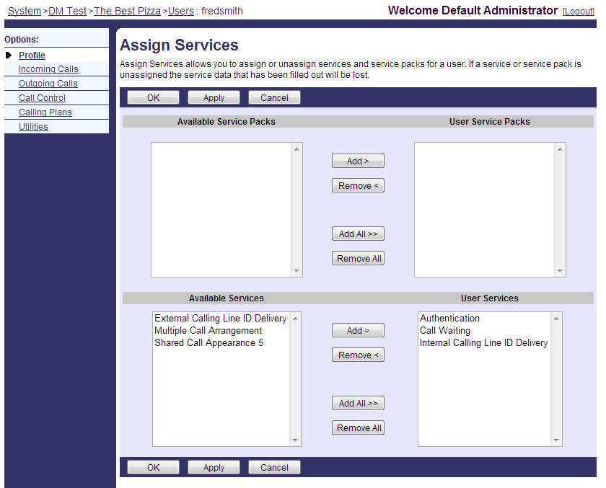

Figure 31 Service Assignment for private user lines

The provisioning of the private user lines is complete on BroadWorks and is ready for device provisioning and registration. The device provisioning requirements will be discussed in the following section.

## Device Configuration Requirements

### Supported Device Models

|  |  |
| --- | --- |
| **Supported Device Models** | |
| Vendor | **Device Models** |
| Aastra | Aastra 675xi, 673xi |
| Cisco | Cisco SPA-500, Cisco SPA-300 |
| Polycom | SoundPoint IP and VVX models (line keys share the same label). |
| Yealink | Yealink T3x, VP530 |

### Device Requirements

To support the Key System solution the device must support the following capabilities:

1. The device must support the BroadWorks Shared Call Appearance feature.
2. The device must be able to assign multiple line keys to a single line on the phone.
3. The device must be able to assign one call appearance to each line key or provide the ability to roll a new call over to the next free line key.

An example provisioning is shown for the Cisco SPA-500/300 series phone models. The configuration detail below shows how the Cisco SPA-500/300 series phones maps a line key to a line and defines a label to that key.

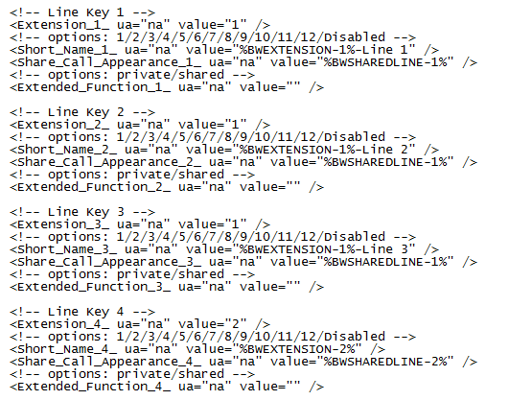

Figure 32 Cisco SPA template file with Device Management Tags

The Extension parameter for each line key is assigned a value of “1” linking each line key to line 1 on the device. The short name value is defined with the label for each line key. In this field we use the Device Management tag %BWEXTENSION-1% plus “-Line X”. In our example this will resolve the labels for the first 3 Line Keys as *“1010-Line 1”, “1010-Line 2” and “1010-Line 3”.* The %BWSHAREDLINE-1% defines each of these line keys as a *“shared”* line.

The Cisco phones will support up to 9 call appearances on a single line. To allow the phone to use a call appearance on a line key and then roll over to the next line key for the next call, the line mapping parameter must be defined to “Vertical First”.



Figure 33 Enable line key rollover

Call Services like transfer, conferencing and forwarding should be enabled at the device. See the provisioning item below. This configuration will enable the feature soft keys on the device.

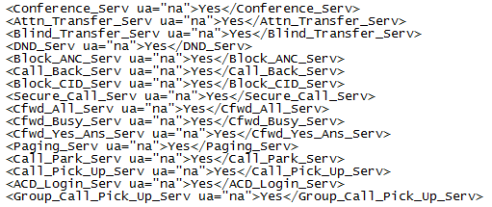

Figure 34 Enable enhanced feature keys on the device

### Device Configuration Details

In addition to the above device configuration example, more details for KTS device configuration can be found in the following Partner Configuration Guides (PCGs).

(http://xchange.broadsoft.com/php/xchange/support/broadworks/integration/cpe)

* Yealink
* Grandstream
* Fanvil
* Polycom coming with R20 update